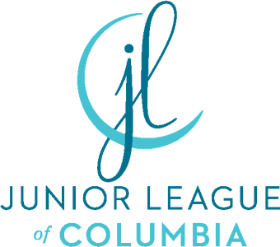

Junior League of Columbia Done in a Day Project Application

In order to be considered for a Done in a Day (DIAD) project, please submit the following information to DIAD@JLColumbia.org.

Please note the following changes: in order to be considered for a Done in a Day partnership, the project you are requesting funding and volunteers for must be A NEW PROJECT that has not been completed in the past with DIAD or other JLC committee. This is in an effort to develop permanent partnerships, strengthen our impact on the community, and fulfill our mission as the Junior League of Columbia. Therefore, the request must be original, and we are looking for new and emerging community organizations that align with our focus areas of healthy kids, women and families.

Please remember incomplete applications will not be considered. Applications must be submitted no later than September 1, 2021. DIAD Committee will review and update application status within 7 days of receipt.

Organization/Agency Information
  - Name of agency/organization requesting assistance
  - Agency address
  - Phone number
  - Executive director/president
  - Contact person for projects and title
  - Contact phone number and email address
  - Number of years in operation
  - Mission of agency/organization
  - Description of prior JLC assistance, if any.
10. Organization's tax-exempt status letter

Project Overview
Provide a brief description of the project for which you are requesting assistance. Include in your response the following:
  - Project title
  - Project date and time(s)
  - Funding requested with line item details
  - Total cost of the project and expected number of participants impacted by the project
  - Number of volunteers needed. Keep in mind that our volunteers are utilized for 3-hour shifts. How many shifts would you require and how many shift workers per time slot.

Project Details
- Describe the project itself. How do you envision the day will go?
- Describe the community need that the project will fulfill.
- Explain the special training needed or preferred for the volunteers, if such special training is necessary.
- Explain whether the project implicates any safety concerns for the volunteers.
- Explicitly state how this project relates to the Junior League of Columbia’s focus area of healthy children, including specifying which subcategory of the JLC’s healthy children focus the project addresses, children in the schools or children in the community.
- Explain the planning steps completed by the organization. Please keep in mind, The Junior League of Columbia is not responsible for fulfilling the needs for venues, guest speakers, food vendors, etc.
- Explain the measurable outcomes for the project, as we expect they will be reported to the community at-large.

